PJP Newsletter Sweep
Lukas Benes
Table of Contents

PJP Newsletter Sweep — Solution Consultant Exercise Submission
Submitted by: Lukas Benes For: Pickle Jar Partners (PJP) Built on: Duvo

What I built
A Duvo agent that gives PJP back two to three hours every morning. It reads the day’s Axios Pro Rata, cross-references the names against PJP’s CRM, drafts personalized outreach emails for every match, and scores the unknown companies against PJP’s investment thesis so they stop running their “should we reach out?” decision on feelings.
The whole thing is one agent in Duvo, one custom skill, one thesis file, two connections (Gmail + Google Sheets), and a daily 8:30am trigger. PJP won’t touch it. Each morning, drafts land in their drafts folder and ONE unified morning brief lands in their inbox — header counts, drafts grouped by relationship type, watchlist ≥ 7/10, negative-news watch. Five minutes to review, click send on the drafts they want, get on with their day.
A live run that produced this output is here: https://app.duvo.ai/agent/7575974c-fb23-4b54-8c15-ed8595b7c5f3?runId=bf4ccb4b-102e-4132-bb5a-58cb91852061

How it works
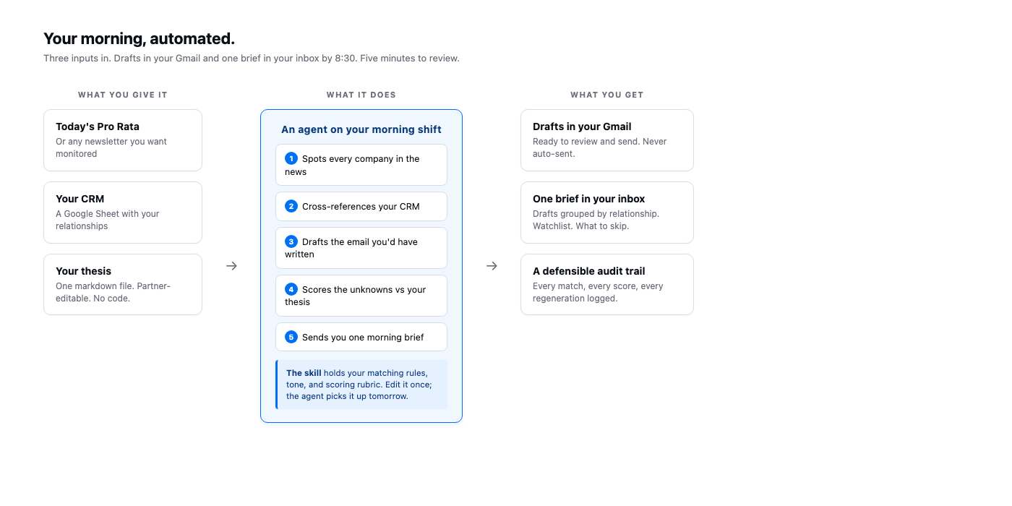
PJP Newsletter Sweep flow

The three pieces under the hood
1. The Duvo Agent (pjp-newsletter-sweep) — the orchestration. SOP describes the workflow, connections handle Gmail and Google Sheets, the schedule runs it every morning. Zero touch from PJP after setup.
2. The custom skill (SKILL.md) — the brain. Source of truth for HOW each step is performed: - Company-name normalization (legal suffixes stripped including inc, pbc, pty) - Match priority: domain → exact normalized name → two-direction substring with asymmetric guards → fuzzy ≥ 0.88 - Ambiguity guards for one-word names (Plaid, Ramp, Brex, Notion, Scale, etc.) — require a domain hit or context word from a per-company list before matching - Same-CRM-company dedup with news_type priority (one match → one draft, even if mentioned twice in the same issue) - Email drafting hard rules: greeting required (Hi <FirstName>,), real congratulations word required, em-dash (—) banned (the strongest AI tell), real CTA required (specific offer or proposal, not just “Cheering you on”), per-relationship word counts (Portfolio 45-110, Pipeline 65-130, Network 25-80), per-news-type opener scaffolds, contact-is-or-isn’t-the-news heuristic, sign-off enforced - 28+ banned phrases (AI smell + VC-speak + source attribution) - Critique-and-regenerate loop with up to 2 retries on rule failures; only the final draft is saved (never duplicate drafts in Gmail) - 10-point fit-score rubric for non-matches that replaces PJP’s “feelings-based” decision - Unified morning-brief format
3. The thesis (pjp_thesis.md) — partner-readable, partner-editable. Defines stage range, priority/adjacent/avoid sectors, geography, scoring rubric, watchlist threshold. The agent reads this file on every run; partners update it quarterly without touching any code or SOP.
The skill + thesis are the durable pieces. If PJP wants to add a Phase-2 portfolio-prep agent next month, it’s a new SOP using the same skill and thesis. Reusable knowledge compounds.

Why a rule-based matcher inside an LLM agent
The matching step is not an LLM call. Matching is exactly where LLMs hallucinate (“Notion” matched against a paragraph that just used the word “notion” prosaically, or “Figma Software (Pty) Ltd” matched to CRM Figma when it’s a different South African company). Determinism here is worth the brittleness — we’d rather miss a match (which a partner will catch when they skim the issue) than draft a wrong-recipient email. The LLM is reserved for the two places where judgment actually matters: pulling structured mentions out of unstructured prose, and writing the email itself.

What we shipped vs the first draft
The first run of the agent worked but the drafts had two systematic flaws: every email contained at least one em-dash (the strongest AI tell), and every email closed with “Cheering you on” — a sign-off, not a CTA. Within an hour of seeing the output we tightened the skill: banned the em-dash character explicitly, added a real-CTA requirement with detection markers, expanded the banned-phrase list from 4 phrases to 28, and added a critique-and-regenerate loop that rejects drafts failing the rules and regenerates with explicit failure reasons. We also unified the previously-separate “watchlist email” and “drafts in Gmail” into ONE morning brief — a single inbox email partners read first thing.
The point of calling this out: this is what Solution Consulting on Duvo looks like in practice. We didn’t ship the first version. We shipped, looked at the output, tightened the skill, and re-shipped — without touching the SOP, without redeploying, without any rebuild. Same agent, better drafts, in 30 minutes.

What’s in this submission
File | Purpose
This document | The write-up (Part 1) plus testing instructions (Part 2, appendix).
SKILL.md | The custom Duvo skill — also live in the workspace as pjp-newsletter-sweep. Sent as .md because that is the file format Duvo expects.
newsletter_normal_day.txt | Test input 1 — happy path.
newsletter_quiet_day.txt | Test input 2 — zero-match day.
newsletter_adversarial.txt | Test input 3 — name-collision traps.
newsletter_edge_cases.txt | Test input 4 — legal-suffix variants, fuzzy match, dedup.
pjp_thesis.md (bonus) | The partner-readable investment thesis the agent reads on every run for non-match scoring. Not required by the brief; included to show how I’d structure a partner-editable knowledge artifact.
To validate the agent: drop any of the four .txt files into the agent’s input, run, and compare the output against the expected outcomes in Part 2 of this document.

What’s already provisioned in Duvo
In your workspace under lukas.benes@insead.edu:
- Skill pjp-newsletter-sweep (id 91243588-088a-4e51-a0a8-b761c29aeea8) — current version with em-dash ban, CTA requirement, two-direction substring matcher, dedup, unified-brief format.
- Agent pjp-newsletter-sweep with a slim SOP that delegates all rules to the skill.
- A successful live run: view it here

Phase 2 candidates
Three obvious follow-ons, ordered by effort:
- Multi-source. Drop in PitchBook Daily, Strictly VC, Term Sheet without changing the skill — same matching and drafting logic, more input.
- Watchlist actions in the Activity Inbox. Today the watchlist is read-only. Phase 2 routes “Linear scored 9/10 — draft cold outreach via Accel?” to the partner’s Activity queue; one click → personalized cold-email lands in Gmail drafts.
- CRM auto-enrichment. Watchlist hits with high fit scores become new CRM rows with the news as the first note. Closes the loop so the CRM grows without manual data entry.

What this saves PJP
- 2-3 hrs/day × 4 partners + office manager = roughly 10-15 hours/day reclaimed
- Zero misses from name variations, typos, or “I forgot to scan today”
- A defensible, auditable answer to “should we have reached out to ?” — replaces a feelings call
- Faster outreach. First-to-congratulate matters in a relationship business; an 8:35am draft beats a 10:30am one.

Appendix: Testing Instructions
The agent is already provisioned in the workspace and producing output. The fastest way to validate it is to feed it the four test newsletters described below and check the result against the expected outcomes.

Quick test on Duvo (5 minutes)

Setup
The agent and skill are already in the workspace:
- Skill: pjp-newsletter-sweep (id 91243588-088a-4e51-a0a8-b761c29aeea8)
- Agent: pjp-newsletter-sweep — slim SOP that delegates all rules to the skill
- Working live run: https://app.duvo.ai/agent/7575974c-fb23-4b54-8c15-ed8595b7c5f3?runId=bf4ccb4b-102e-4132-bb5a-58cb91852061
The agent reads: - The day’s Axios Pro Rata newsletter (or a local file in /workspace/) - The CRM (Google Sheet, CSV-export over Enterprise Browser) - pjp_thesis.md (also at /workspace/)

What to do
- Drop one of the test newsletter files into /workspace/ (or paste the body into the agent’s input).
- Run the agent.
- Review three outputs:
  - Gmail Drafts folder — one draft per match.
  - Inbox — one unified morning brief email summarizing drafts + watchlist + negative-news watch.
  - /workspace/pjp_newsletter_sweep/<date>/ — run_log.md, morning_brief.md, email_drafts.md.
- Compare against the expected outcomes below.

Test inputs
Four .txt files, each exercising a different category of failure mode.

Test 1 — newsletter_normal_day.txt
Validates: the happy path — strategic mix of news types and relationship tones, plus the negative-news guard.
Expected: - ~17 mentions extracted, 13 CRM matches, 12 Gmail drafts (Deel layoffs is matched but no congrats draft is created) - Watchlist of 3: Linear (≥9/10), Mercury (≥8/10), Vercel (~7/10) - Coinbase correctly excluded (off-thesis) - Negative-news watch surfaces Deel - Every draft passes the email hard rules (greeting, real congrats, no em-dash, real CTA, sign-off, length within range)

Test 2 — newsletter_quiet_day.txt
Validates: the “0 matches” path — the agent must handle a quiet day gracefully.
Expected: - 5 mentions extracted, 0 CRM matches, 0 drafts, 0 on watchlist - Morning brief still composed and sent — watchlist section reads “No new companies passed the watchlist threshold today. 5 mentions reviewed and logged.” - No errors, no exceptions, no paging

Test 3 — newsletter_adversarial.txt
Validates: the matcher’s name-collision guards. Every mention is a trap.
The traps: - “RAMP Logistics” (a YC startup, no relation to Ramp the spend-management company) - “Brexley Industries” (a defense-staffing firm, unrelated to Brex) - “Linear Plus” (an open-source fork, unrelated to Linear) - “Striped Capital” (a new fintech by ex-Stripe engineers — story is about the new company, not Stripe) - “Figma Software (Pty) Ltd” (a South African accounting vendor, unrelated to Figma) - Plus prosaic uses (“scale our digital practice”, “the notion of building in public”) that should never become matches
Expected: - 0 CRM matches, 0 drafts - Run log shows each trap rejected with a precise reason (e.g., substring_long_skipped_no_corroboration:figma~=figma software)
This is the test that proves the matcher fails closed on adversarial input — every drafted email goes to the right person or no email gets drafted at all.

Test 4 — newsletter_edge_cases.txt
Validates: the trickier-but-legitimate matching cases.
The cases: - “Stripe, Inc.” → matches Stripe (legal-suffix stripping) - “Anthropic, PBC” → matches Anthropic (PBC is in the legal-suffix list) - “Anthropic, PBC” mentioned twice in different sections → dedup to one match - “Rippling Inc” → matches Rippling - “Airtable Holdings” → matches Airtable (substring + context word) - “Plaide” (typo) → matches Plaid (fuzzy or substring + context) - “Notion AI Mail” → matches Notion (substring + context word “workspace”) - “Anthropic Capital, an unrelated boutique law firm” → does NOT match Anthropic (substring + no context corroboration → rejected) - “Stripe announced Sarah Chen has been promoted to CPO” → contact-is-news heuristic kicks in; draft is direct congrats to Sarah, not third-person about her team
Expected: - 6 deduped matches, 6 drafts (down from 7 pre-dedup — Stripe collapsed from 2 to 1, keeping the higher-priority news_type) - Anthropic Capital correctly excluded - Sarah Chen’s Stripe draft uses direct-congrats tone

What “passing” looks like for every draft
Regardless of which test newsletter is fed in, every draft must satisfy all the email hard rules. Check each draft body for:
Rule | What to verify
Greeting | Opens with Hi <FirstName>, on its own line
Real congratulations | Body contains congrats, congratulations, well done, kudos, big move, or huge congrats
No em-dash | No — character anywhere in subject or body — if present, the rule was bypassed
Real CTA | Body contains a specific offer or proposal, detectable by markers like ?, happy to, let me know if, looking forward, if useful, open to, drop me a, would love to, free for
No source attribution | Body does NOT mention Pro Rata, Axios, the newsletter, this morning, front and center
No extractive asks | Body does NOT contain “I’d love to hear your read”, “compare notes”, “from your seat”, “from your vantage point”
Sign-off | Ends with Best, <PartnerFirstName>
Length | Within range for the relationship: Portfolio 45-110, Pipeline 65-130, Network 25-80 words
Subject | < 50 chars, specific to the news event, no Saw/Axios/Pro Rata/Quick note tokens
The skill defines all of these. The critique-and-regenerate loop in the skill enforces them automatically — drafts that fail any rule are regenerated up to 2 times, and only the final passing draft is saved to Gmail.

What’s already on the workspace
- Skill: pjp-newsletter-sweep — uploaded with em-dash ban, CTA requirement, two-direction substring matcher, dedup, banned-phrase list, critique loop, and unified-brief format.
- Agent: slim SOP that delegates all rules to the skill (single source of truth).
- Live run: the link above. The output looks correct on first inspection — drafts have greetings, real congrats, real CTAs, no em-dashes, varied subjects.
If the agent’s behavior diverges from any of the expected outcomes above, the run log explains why for every decision the agent made.

